Geometry: Unit 10, Lesson 3
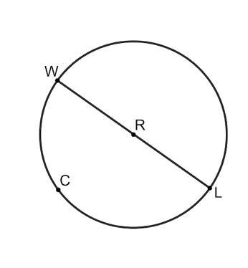
- Circle $R$ is shown with points $W$, $C$, and $L$ on the circle. Point $R$ lies on $\overline{WL}$. What is the ratio of the measure of the central angle, $m∠WRL$, to the whole circle?

$$\frac{1}{2}$$

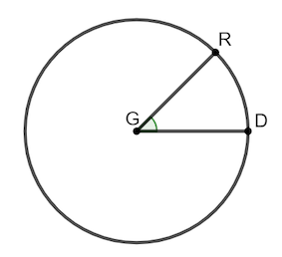
- Circle $G$ is shown where $∠RGD$ is a central angle. If the circumference of circle $G$ is $3π$, what is the length of $\overline{GR}$?

$$\frac{3}{2}$$

- What is a true statement about central angles?

The ratio of the central angle to the whole circle is the same as the ratio of the length of an arc to the circumference.

